iOS Feedback 10/19/2020

Search's Feedback

I've added 2 subservices under the "HOGAR" category to test

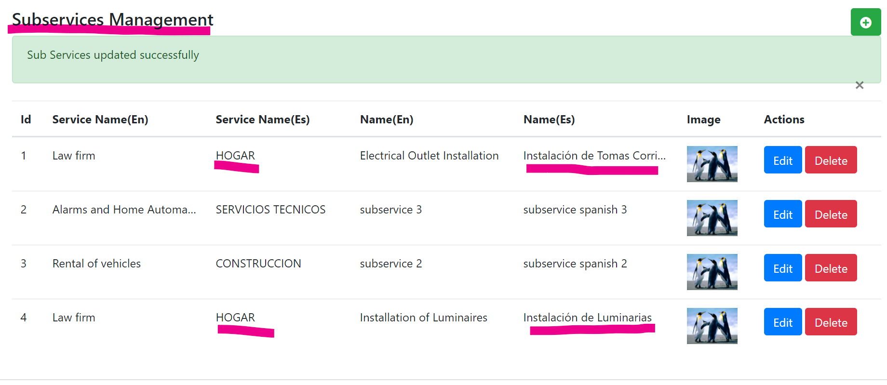

The services and sub-services should be searchable but they're not showing.

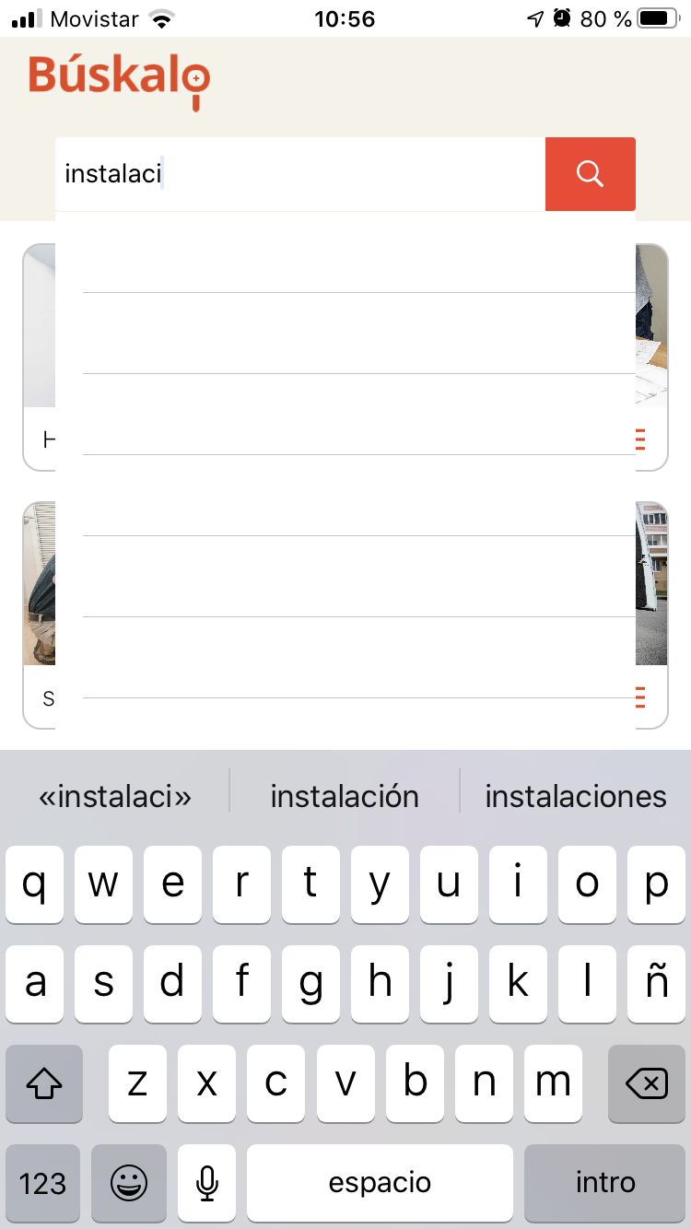

According to the latest version delivered we see that "Mi Cuenta" menu already presents the customer information.

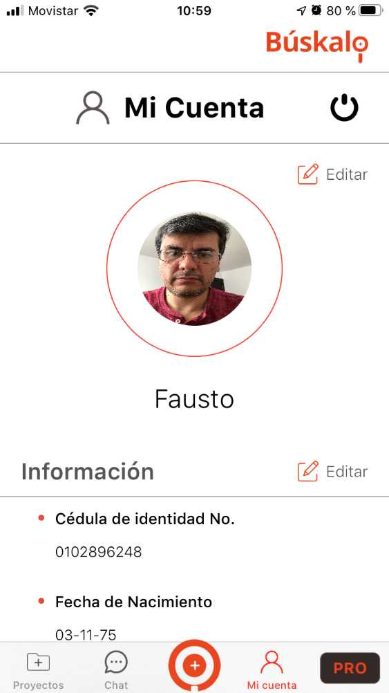

by editing my account information, and locating ourselves in the address edition:

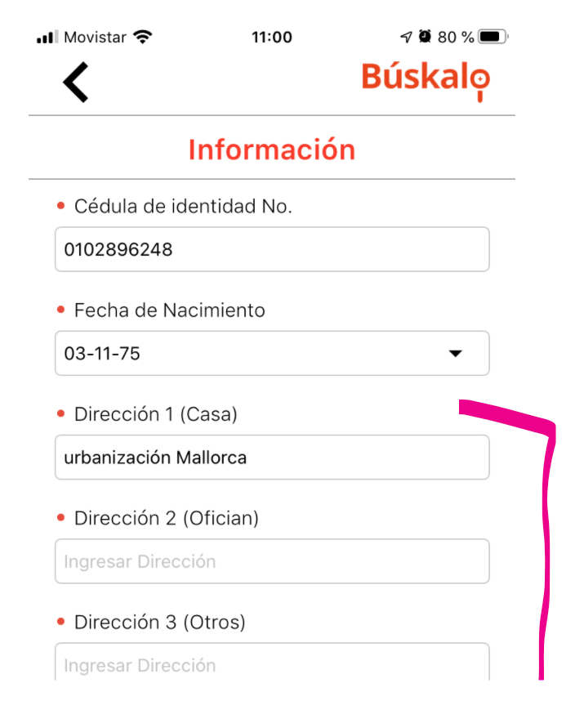

the geo-location map is not displayed

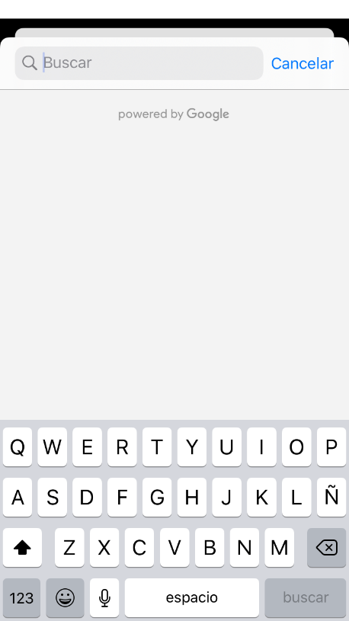

When the questionnaire is done, if the user has been registered the available info should be auto-filled (Name, phone number, email, etc.) the address can be ask to make sure where they need that specific job performed.

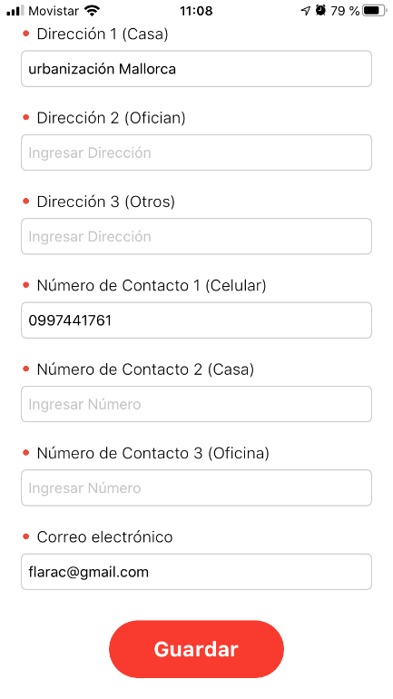

These following screens should be auto-filled and have the option to change if needed:

Customer Name

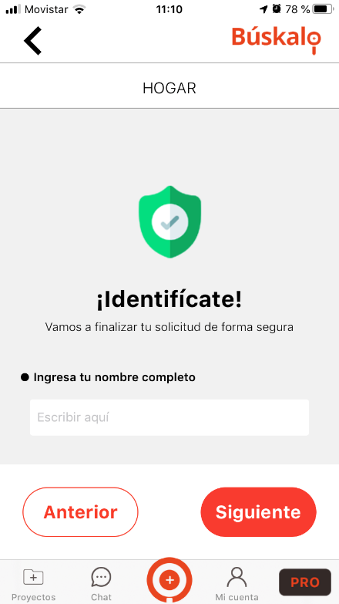

Phone number, field “Numero de Contacto” customer profile

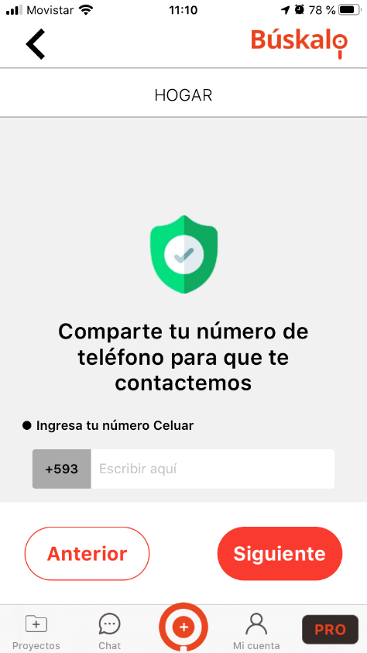

registration email, field “correo electrónico” profile customer

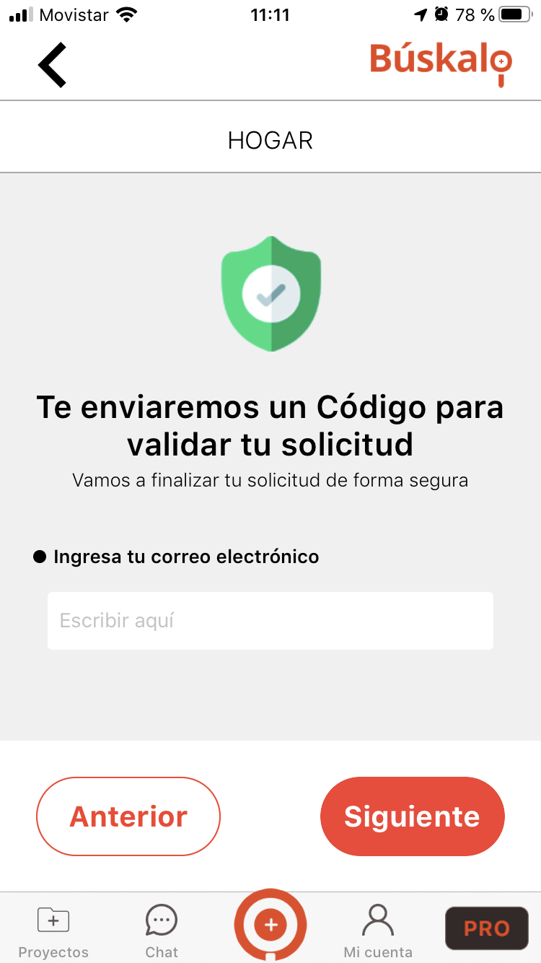

There is a problem with the Otp code, because sometimes is sent it right away but most of the times take a while even we've gotten in a couple days, this needs to be fixed, we need to make sure to get them on that moment.

Because of this issue these flows are pending for validation:

Menu "Proyectos"

Menu "Chat"

MENU “PRO”

Not being able to finish with the entry of a service request, I cannot create opportunities so the professional menu cannot be validated either "Trabajos", "Oportunidades", "Chat"

"ingeniro Elect" is shown below my name, I have not entered that info and don't know how to change it, please revise.

In the previous registration I had already loaded the image of the professional, however it is not showing.

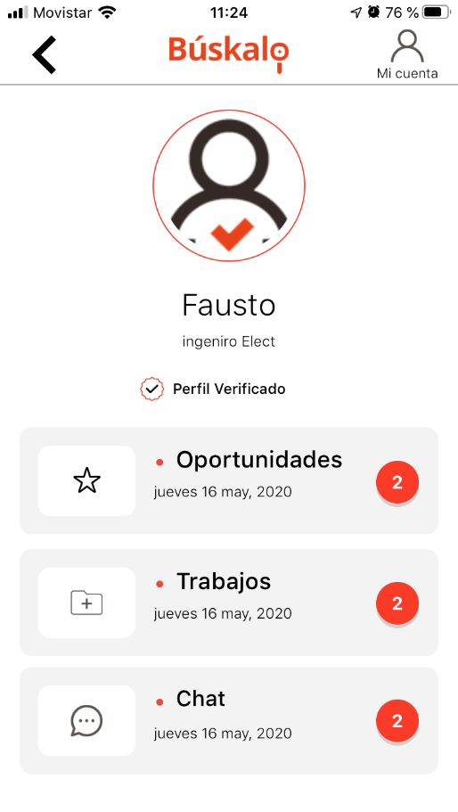

When I try to go to the menu "Mi Cuenta" the application is shutting down.

